Project overview
The Routines Activation Power BI solution monitors how consistently operational “routines” are being activated across the full customer lifecycle, including Sales, Field Services, 7-Day Visits, Collections, Customer Care, and Customer Service.
The report is designed for senior operations and commercial leaders who need a single view of activation rate, volume, and routine usage by country, customer type, and branch to drive performance management and process compliance.​
Data sources and integration
This solution brings together data from three enterprise systems: a PostgreSQL operational database, SharePoint files (ad-hoc and manually curated logs), and Snowflake for centralised, high-volume datasets.​
Using Power Query, the raw tables (Sales_data, Branches_info, IE_Branches_info, CUS01_CUSTOMER, Country, Customer_type, FS, Tickets, CC_agents, etc.) are cleaned, merged, and conformed to produce a consistent set of dimension and fact tables, including shared keys for customer, branch, and date to support cross-department analysis.​
Data modelling and date intelligence
The model follows a star schema, with a single central Date table driving all departmental fact tables (Sales, Field Services routines, Collections, 7-Day Visits, Tickets, Scheduled Services, etc.), which aligns with performance and best-practice guidance for Power BI.​
The Date dimension includes period attributes and time-intelligence flags (week, month, quarter, year, current vs previous period), enabling consistent calculations of activation rates by date, 7-day visit windows, and trend analysis across every page in the report.​ 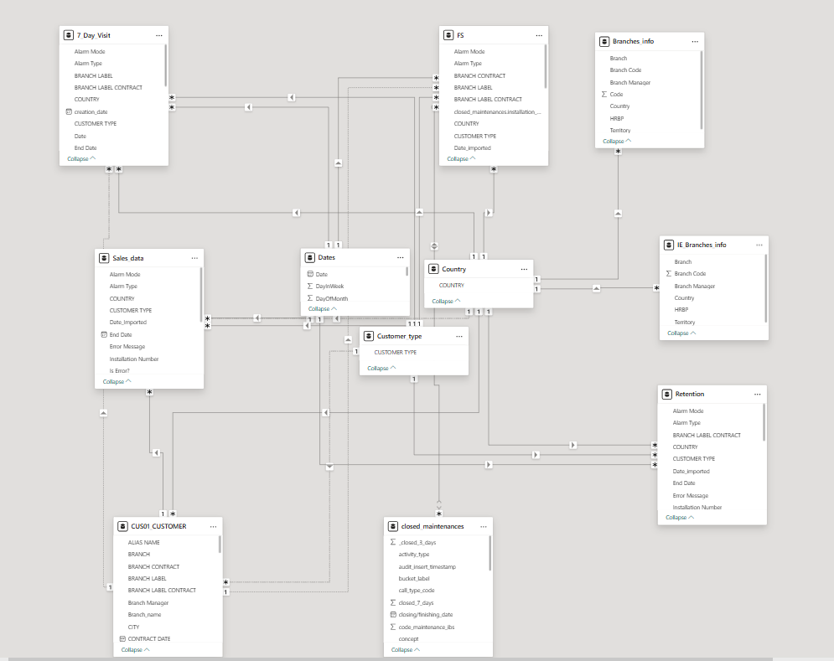
Business logic and DAX measures
Core KPIs are implemented as reusable DAX measures rather than duplicated columns, including: total interactions (sales, services, visits, or tickets), routines activated, and activation rate per department.​
Activation rate is defined as routines activated ÷ eligible interactions, and all measures are fully filter-aware so that changing country (UK vs Ireland), customer type (Residential vs Business), date range, or branch context dynamically recalculates the gauges, cards, and charts.​
Advanced navigation and UX design
The overview page provides a high-level snapshot of activation performance for each department, with consistent gauges and KPI cards to make cross-functional comparison easy for executives.
Interactive icon-based bookmarks allow users to toggle between UK and Ireland data via flag icons and to switch between Residential and Business customers via dedicated icons, creating an app-like experience instead of cluttered slicers.​
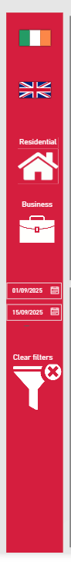
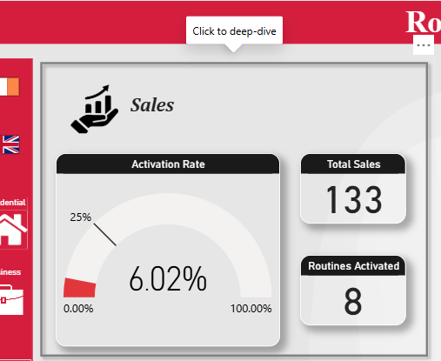
Clicking on the Sales tile navigates to a dedicated Sales Overview page (and similarly structured pages for 7-Day Visits, Field Services, and Customer Care), using bookmarks and buttons for seamless page navigation.​
The Sales deep-dive includes:
- KPI cards for Total Sales, Routines Activated, Activation Rate.
- Routines by branch bar charts showing how many routines are activated per location.
- Sales by branch ranking to highlight high-volume sites.
- An Activation rate by Date time-series visual for short-term trend monitoring.
- A detailed “Sales by routine flag” table listing installations, routine names, dates, and activation flags to support root-cause analysis and coaching at record level.
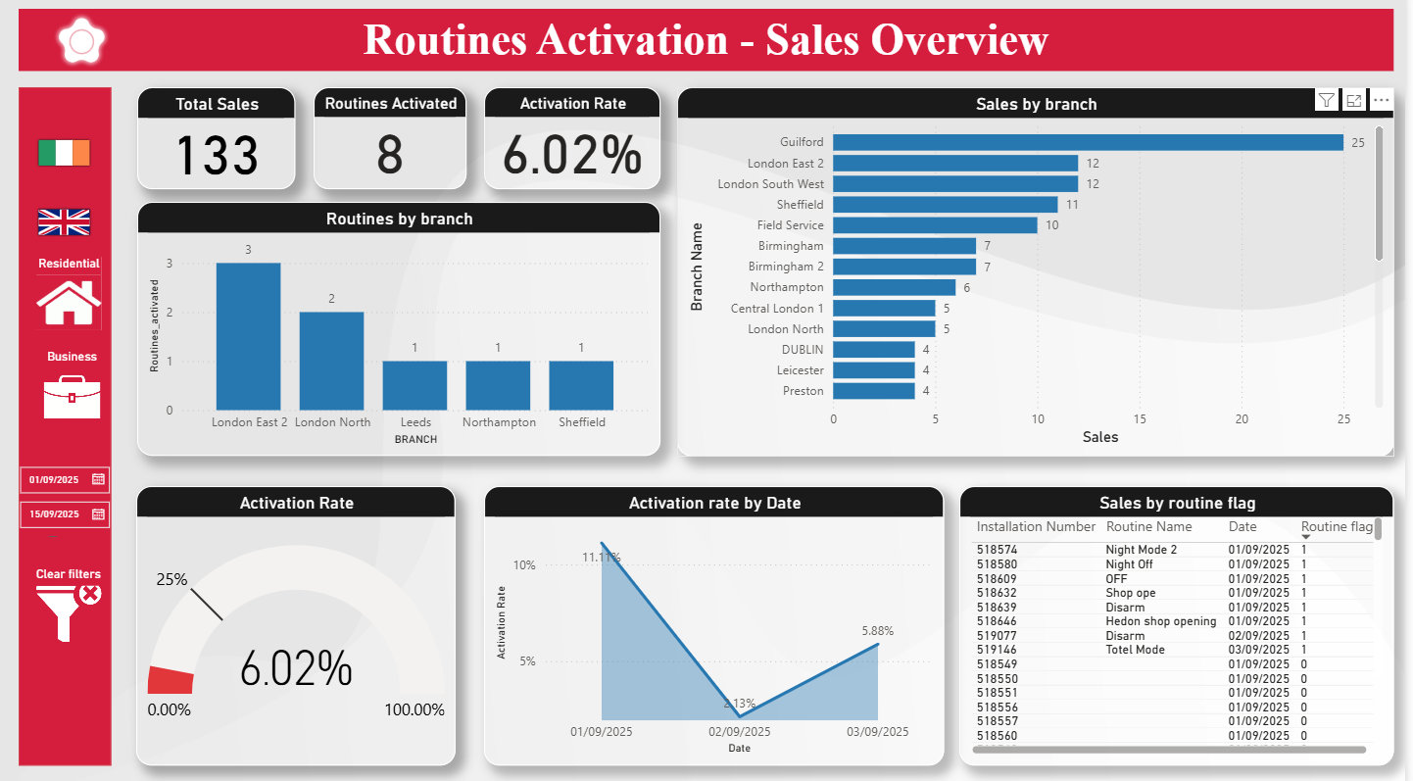
Performance optimisation choices
The report is built with performance in mind, following enterprise optimisation practices:
- Lean star schema with only required columns and rows retained, and text fields reduced where possible to improve VertiPaq compression and query speed.​
- Preference for Power Query transformations (merges, derived columns, type conversions) instead of calculated columns, to push heavy work to the data refresh step and preserve report responsiveness.​
- Use of import mode for core fact tables with appropriate aggregations rather than excessive DirectQuery, balancing freshness and speed; Row-level filters and incremental refresh can be applied where necessary as data volume grows.​
- Controlled visual density on each page (limited number of visuals and interactions) so that executives get a fast, focused experience without overloading the report canvas.​
Business impact and transferable skills
This project demonstrates the ability to translate a complex operational process (multi-department routine activation) into a clear analytical model with consistent KPIs, driven from disparate sources (PostgreSQL, SharePoint, Snowflake).​
It highlights advanced Power BI capabilities: enterprise-grade data modelling, central date table and time intelligence, DAX measure design, bookmark-based navigation, and performance tuning—all directly applicable to sales, service, and operations reporting in real-world organisations.

